CS 255 System Design Document

UML Diagrams

UML Use Case Diagram

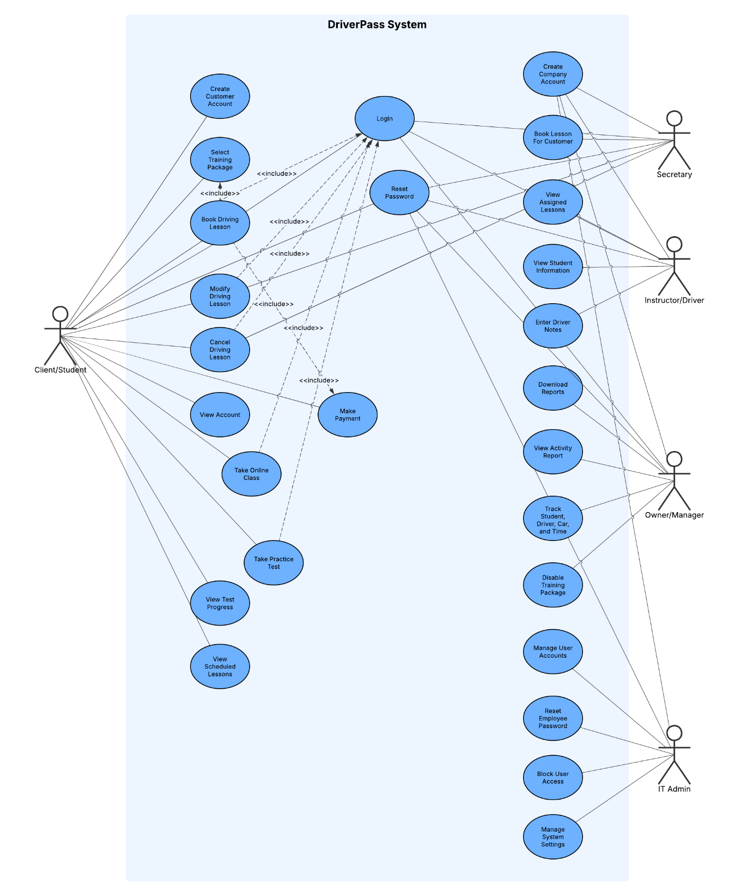

UML Activity Diagrams

Activity Diagram #1 - Booking a Driving Lesson

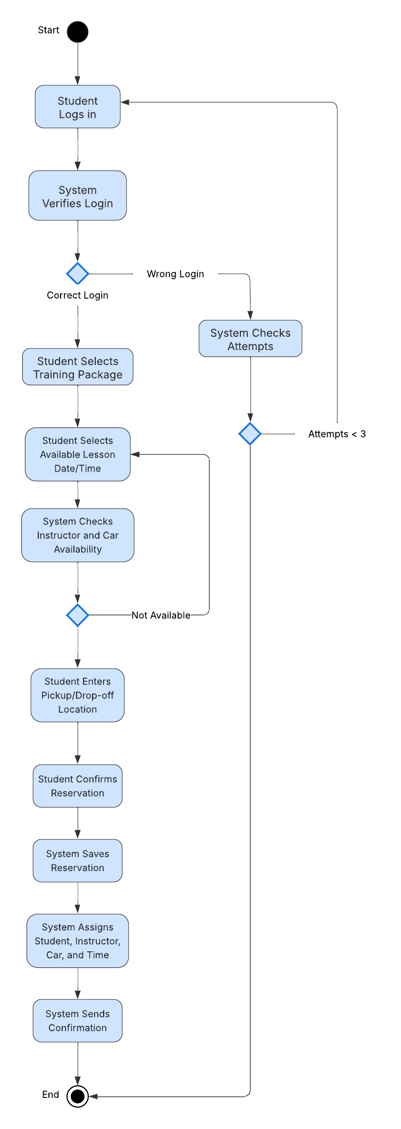

Activity Diagram #2 – Reset Password

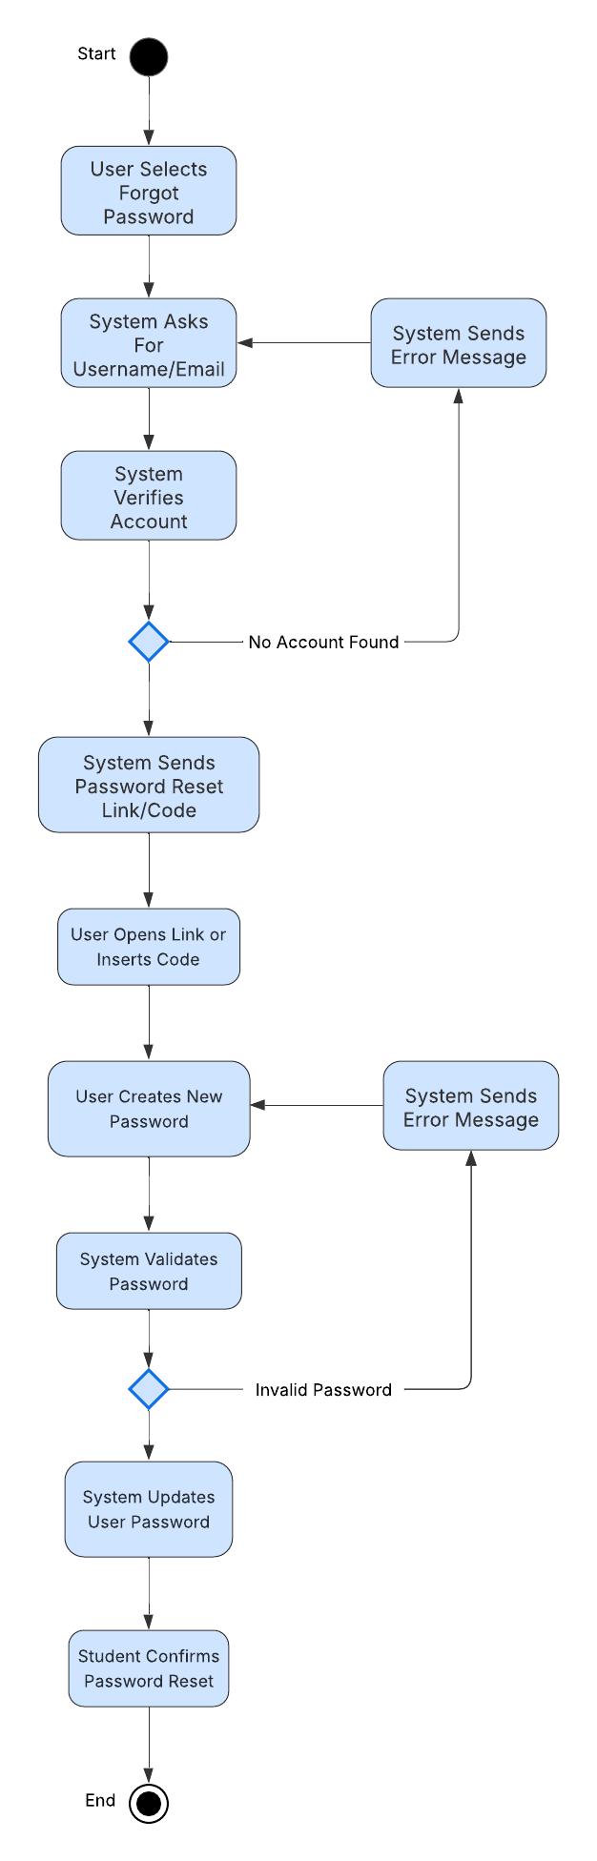

UML Sequence Diagram

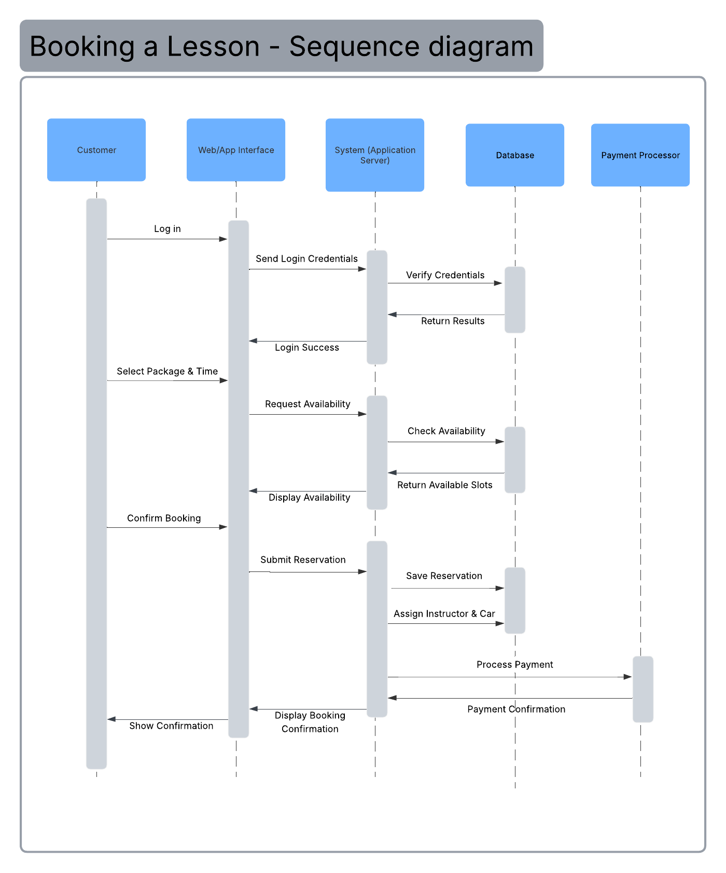

UML Class Diagram

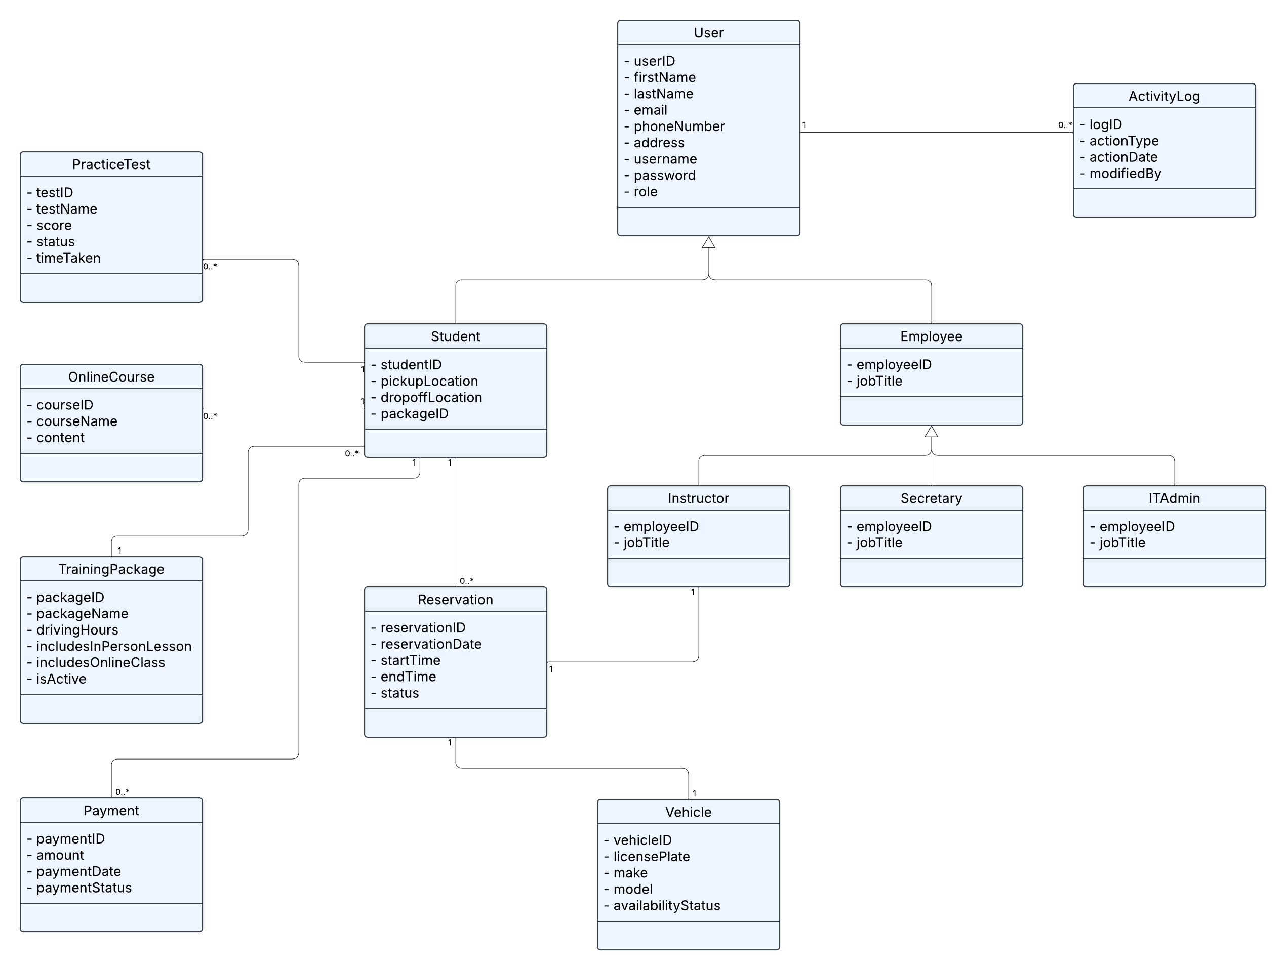

Technical Requirements
The DriverPass system will require a combination of hardware, software, and supporting infrastructure to ensure it functions efficiently and meets the client’s needs.
Hardware Requirements
- The system will be hosted on cloud-based servers to allow users to access the platform from anywhere with an internet connection.
- End users (students, instructors, secretary, and admin) will be able to access the system using standard devices such as desktops, laptops, tablets, and smartphones.
- The system should support modern hardware capable of running web browsers and mobile applications without performance issues.
Software Requirements
- The system will be a web-based application accessible through commonly used browsers such as Chrome, Safari, Edge, and Firefox.
- A backend application server will be required to handle business logic, including user authentication, scheduling, and data processing.
- A relational database will be used to store user data, reservations, training records, and system activity logs.
- The system will integrate with an external payment processing service to handle secure transactions.
- The system may also integrate with external services such as the DMV database to receive updates on rules, policies, and practice test content.
Network and Infrastructure Requirements
- The system will rely on a stable internet connection to function properly, as it is fully web-based.
- Cloud infrastructure, such as Google Cloud, will be used to support scalability, reliability, and data storage.
- The system must support real-time updates so that scheduling changes, reservations, and availability are immediately reflected across all users.
Security Requirements
- The system will require user authentication using a unique username and password combination.
- The system will include account lockout functionality after multiple failed login attempts to prevent unauthorized access.
- Role-based access control will be implemented to ensure that different users (students, instructors, secretary, and IT admin) have appropriate permissions.
- The system will allow users to reset their passwords securely if they forget them.
Performance Requirements
- The system should respond quickly to user actions, including logging in, booking lessons, and viewing schedules.
- The system must be capable of handling multiple users at the same time without performance degradation.
- Real-time scheduling updates must occur without noticeable delay to avoid booking conflicts.
Data Management Requirements
- The system will store and manage data related to users, reservations, vehicles, instructors, training packages, and payments.
- A tracking system will log all actions such as booking, modifying, or canceling reservations to maintain accountability.
- Data validation will be implemented to ensure accuracy and completeness of user input.
- The system must support data backup and recovery to prevent data loss.

